**HR Forecast**

**Copyright 2017 - 2018 INCEDO INC**. All Rights Reserved. No part of this document may be reproduced, stored in a retrieval system, distributed or transmitted, in any form, or by any means, electronic or otherwise, including photocopying, reprinting, or recording, for any purpose, without the express prior written permission of Incedo Inc.

**REQUESTS** For information requests or for obtaining permission for the use of this work, please submit a written request to: Marketing and Communications, Incedo Inc, Plot No. 248 Udyog Vihar, Phase IV, Gurgaon - 122015. Email: communications@incedoinc.com

**Document Revision History**

|  |  |  |  |  |  |
| --- | --- | --- | --- | --- | --- |
| **S.No.** | **VERSION NO.** | **DATE** | **AUTHOR** | **APPROVAL BY** | **Remarks** |
| 1 | 0.1 | 1-02-2018 | Keshaavan  Shanmugam  Ashok  Marcelin  Surya | Incedo Hackathon Evaluation Team / HR Team |  |
|  |  |  |  |  |  |
|  |  |  |  |  |  |
|  |  |  |  |  |  |
|  |  |  |  |  |  |

**Table of Contents**

**1.** **Title 4**

**2.** **Abstract 4**

**3.** **Solution Approach 4**

**4.** **Design Architecture 5**

**5.** **Business Impact: 6**

**Title:**

Recruitment Data Modelling and Analysis: Model Incedo recruitment data and predict propensity of offered candidates not showing up after offer acceptance.

**Abstract**

We made an offer to an employee and he’s agreed to join your company. You proceed to call him on his joining date and there’s no answer! You try reaching out to him via email or texts but you still can’t connect with him. A few days later, you check his LinkedIn profile and find out that he’s working for another organization.

Does this sound situation sound familiar?  Candidates backing out are a true nuisance for recruiters and employers alike. It adds to the workload of the HR department, and also contributes to higher hiring costs for the employer. Moreover, the position that needs to be filled remains vacant adding further liability.

HR predict is the one of the most efficient tool to predict and find the most possible joinee. As per market standard Salary, Location, Role and other factor determine the joining factor. Based on the market study the HR predict is configured to predict the right candidate to roll out the offer. This is analytical tool use the past historical data. So the accuracy will be 95% perfect most of the time.

**Solution Approach**

**Problem:** Currently all organization struggling to find the right candidate to roll out the offer. Most of the time offered candidates not showing up after offer acceptance. There is a lot of investment involved in recruitment process from the beginning to end. So if the candidate didn’t join then its is kind of revenue loss for the company..

**Advantage of HR Forecast**: In the present system the HR has to rollout the offer based on the input given by the final interviewer. As per NASCOM study most of the time it will not work out and there are other factor should be taken into consideration before rolling out the offer to the selected candidate, they are Salary, Role, Location etc.,

HR Predict is designed to predict the candidate by weightage configured in the system. HR can configure the system by adding/modifying weightage for each category (ex salary, location etc). The prediction configuration is mostly based on the historical data.

Based on the configuration the system will list the most likely joining candidates. It will ease the HR job to get the candidate on board on time.

The system is designed using R software. It’s a integrated software for data manipulation, calculation and graphical display. The advantages are

1. Effective data handling and storage
2. A suite of operators for calculation on arrays, in particular matrices.
3. A large intergrated collection of tools for data analysis
4. Graphical facilities for data analysis and display
5. A well developed and simple language.

Weightage given based on the following factor

1. Current salary and Expected Salary
2. Current location of candidate
3. Current role and expected role
4. Company benefits

* **Design Architecture**

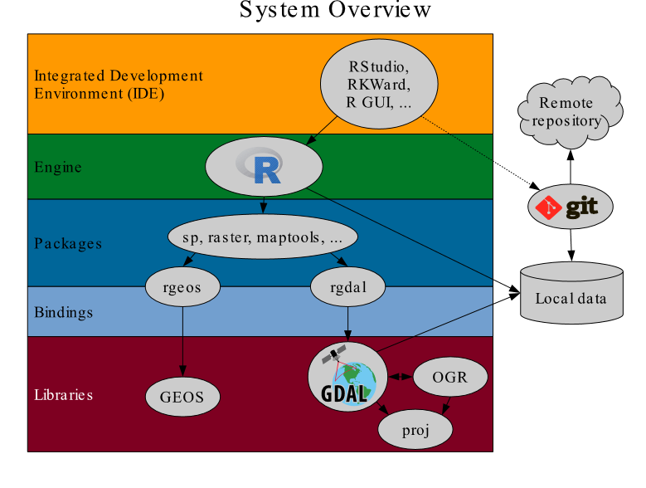

* **Business Impact:**

HR Predict is the one of the best system for HR in onboarding process. This will help the HR to find the best candidate with most possible joinee.

Currently the HR rolling out the offer to the candidate based on the interview panel feedback. It is a time consuming one also most of the time not yielding any result. 80% of the candidate is dropping off after getting the offer letter. So the cost involved in hiring for the drop off is very high. It’s a total revenue loss for the company. In case of new project we may lose the project or place the candidate from the other project and place into new one. It will create over load on the existing employees and over burn them due to sharp dead line.

The advantage of HR Forecast. Company can lots of money involved in internal and external process

1. The company will not miss out a right candidate.
2. External Costs
3. Cost involved
4. Job posting costs
5. External assessments, background checks, etc.
6. Job sourcing
7. Career fair or recruiting event fees
8. Staffing agencies
9. Referral bonuses
10. Internal Costs
11. In-house recruiting staff salaries
12. Talent acquisition system costs
13. Referral rewards
14. Fixed costs (such as office rental, etc.)
15. Interview costs (number of hours spent interviewing multiplied by the hourly salary of hiring manager)